***Educage user guide***

***System assembling-***

1. Connect the analog to digital electronic box to the behavioral chamber via serial cable.
2. Connect the valves to the electronic box.
3. Connect the electronic box to myRIO DIO ports. Use the following wiring map:

DIO0- Lick1

DIO1-Mouse (IR)

DIO2-Valve1 (for water reward)

DIO3- Valve2 (for air puff punishment)

DIO4- External output channel 1

DIO5- External output channel 2

DIO6- External output channel 3

DIO7- External output channel 4

DGND-ground

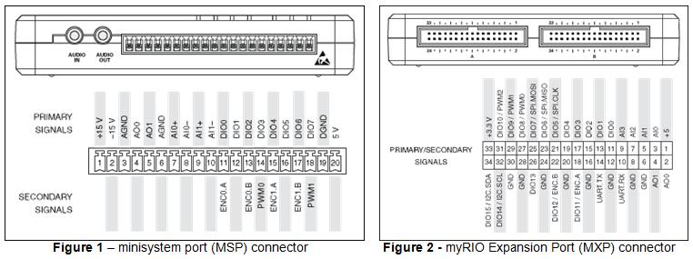

1. Insert your Dorset antenna to the behavioral chamber and reassemble the chamber. Use the following images as a reference:

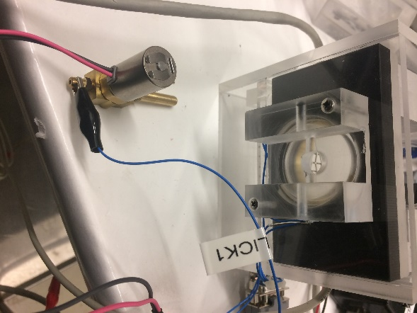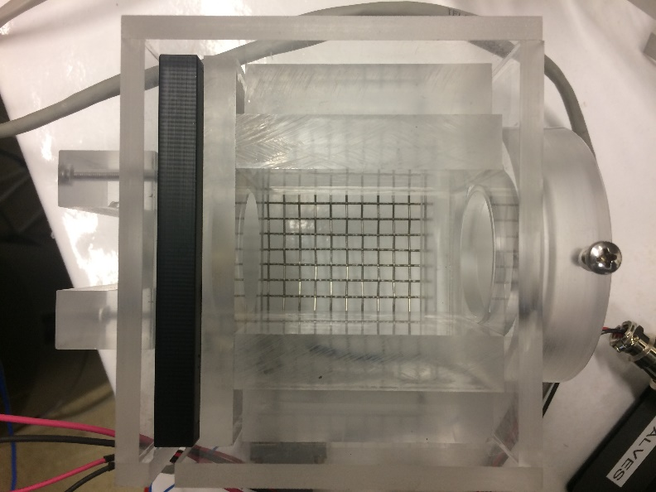

1. Connect the LICK1 connector to the water valve as in the top right image.
2. Connect the valves to your water and air resources.
3. Connect RFID antenna to Dorset decoder (LID665) and the decoder to myRIO DIO (left side – panel A ; ports 10, 12, 14) via serial cable. Use the following wiring map:



1. Plug in the electricity of the Doreset decoder, myRIO and the electronic box and turn on the power of the electronic box.

***Software installation***

1. Install LabView on your working station (preferably a 2015 version) and select the following options (it might take about an hour to complete):

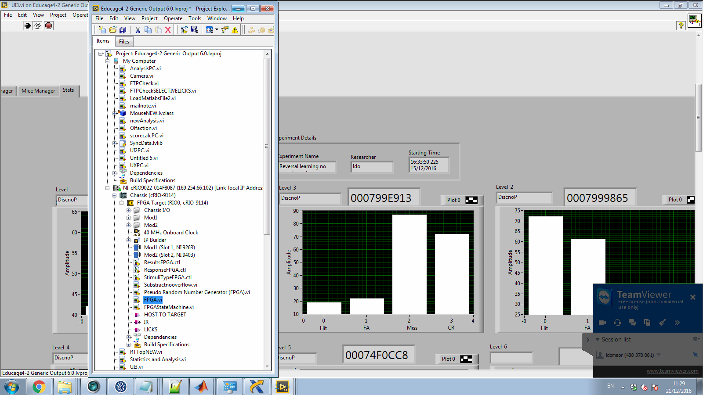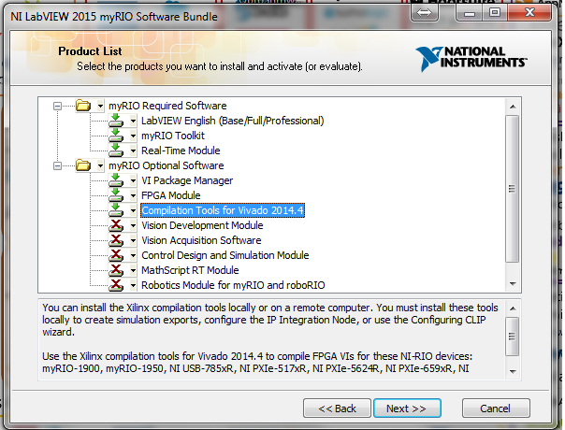

1. Open miniEducage project (after extracting the files).
2. Connect the myRIO via USB connection.
3. Open FPGA VI (see the path on the right)

and run it (press white arrow).

1. When running FPGA vi, you will be prompted to select compilation tool:  
   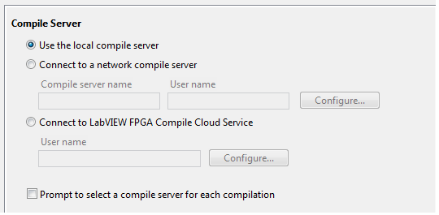
2. Open UI3 VI and run it.

Use this VI in order to operate the system, design experiments and tracking mice performances.



***Run a new experiment:***

**Design level sequence-**

1. Choose the Level Manager tab.
2. Activate level entry.
3. Load desired sequence (drag and drop sequence name from the list to the 'sequence name' window and press- **Load sequence**).
4. Modify level parameters and upload level (see the ‘design level sequence’ section)
5. Upload sequence to system

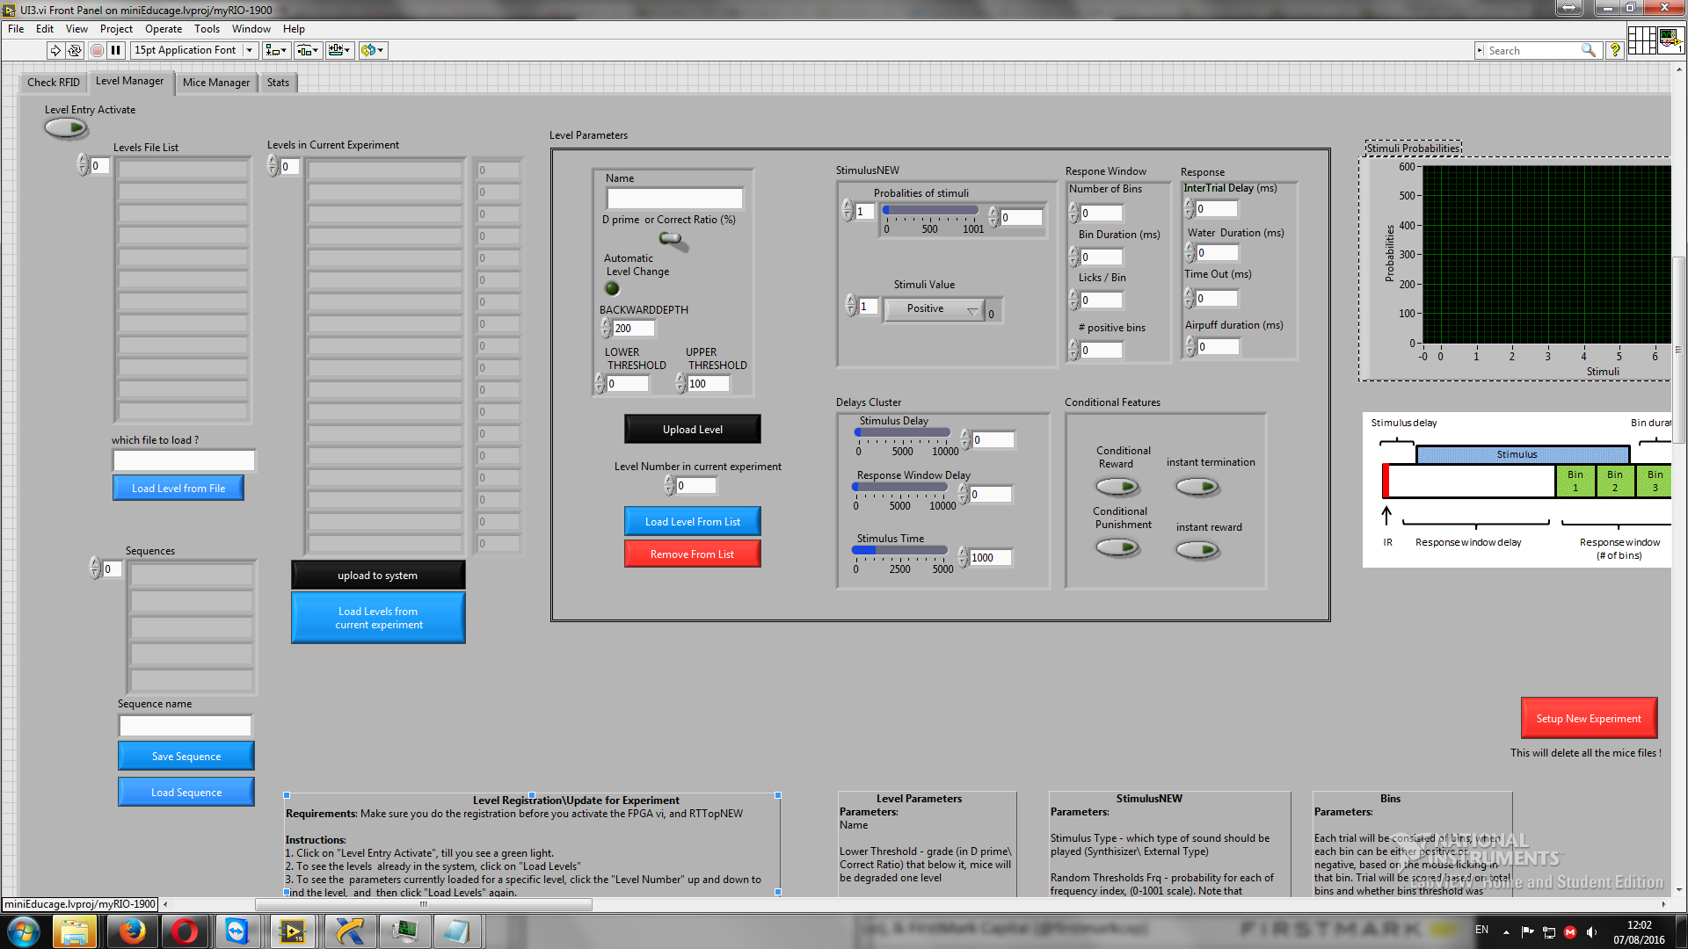

1

4

5

3

2

**Select experimental mice and run experiment**

1. Choose the Mice Manager tab.
2. Activate mica manager tab.
3. Upload experimental mice in the desired level- enter the name of the mice, choose level number and press 'upload mouse parameters'.

(To read RFID chips use the Check RFID tab).

1. Register experiment details
2. Run experiment

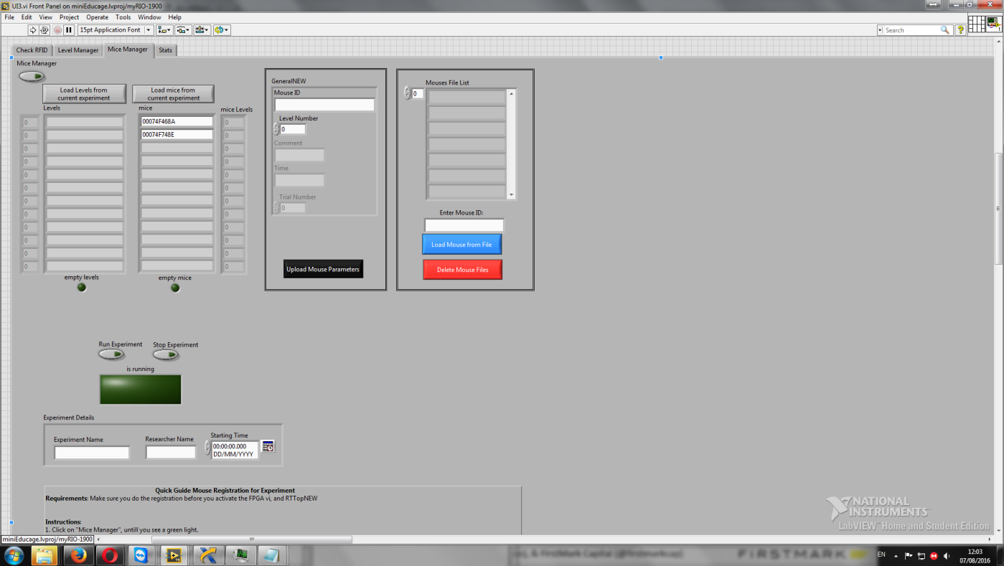

1

3

2

5

4

**Design level sequence**



**Name-** the name of the level, as it will be saved.

**Automatic level change-** if enabled, levels will be transferred according to mice performances:

**d'/Correct ratio toggle-** define score mode

**Backward depth-** number of last trials from which score will be calculated**.**

**Lower threshold-** if score reach this threshold, level will be decrease.

**Upper threshold-** if score reach this threshold, level will be increase.

**Level number in current experiment-** the chronological order of the level sequence. Starting form 0 up to…

**Probabilities of stimuli-** each trial the system generates a number between 0-1000. This number will then be mapped to a specific stimulus according to the delta of the assigned probabilities. For example, if we defined the following stimuli probabilities:  
1 – 100

5 – 500

9 -1001

(and the rest of the stimuli are 0 )

1- Will occur 0.1 of the time.

5- Will occur 0.4 of the time

9 – Will occur 0.5 of the time.

Make sure the last stimulus will get the value of 1001 so all possible generated numbers are mapped to specific stimuli.

The defined probabilities are represented as bar graph on the right figure.

**Stimuli value-** the valance of each stimulus: positive (‘go’ response will be rewarded) /negative (‘go’ response will be punished) /no effect (neutral stimuli without an outcome)**.**

**Stimulus delay-** time from IR breaking (trial initiation) to stimulus onset.

**Response window delay-** time from IR breaking to response window onset.

**Stimulus time-** duration of stimuli (TTL output).

Response window parameters:

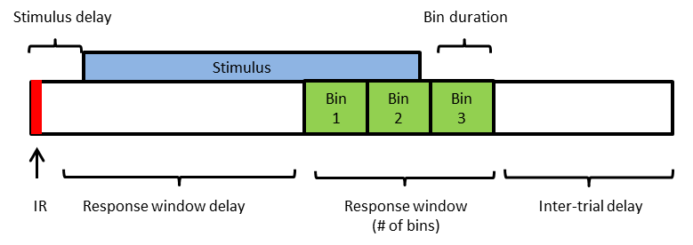

Define 'go' response:

**Licks/Bin-** licks threshold for positive bin.

**# of positive bins-** positive bins threshold.

Conditional features:

**Conditional reward-** reward will be given only if mouse blokes IR at the end of the response window.

**Conditional punishment-** air puff will be given only if mouse blokes IR at the end of the response window.

**Instant termination-** trial will terminated as soon as mouse stopped blocking IR.

**Instant reward-** trial will terminated and reward will be given as soon as mouse reached threshold for 'go' response.